CSCI 5010 – Data Communications

Updated Assignment 2

GNS3 and Cisco Packet Tracer

University of Colorado Boulder

Department of Computer Science

Network Engineering

Professor Levi Perigo, Ph.D.

Here are some steps to install the GNS3 application and download the necessary device images on the application.

Make sure you have access to your VM1 provided. Don’t forget to connect to VPN if you are outside of campus.

**1.1 GNS3 Installation – on VM1 provided.**

1. Download GNS3 using the following link: <https://docs.gns3.com/docs/getting-started/installation/linux/#ubuntu-based-distributions-64-bit-only>

Follow the steps for Ubuntu based machine.

1. Once the setup file is downloaded, run the GNS3 application.
2. The below setup window may be prompted during the installation, select **Run appliances on my local computer**.

1. The application should be successfully hosted at this point and the simulation window should appear.
2. Download the cisco C7200 image from the below link on the provided VM:

<https://drive.google.com/drive/u/1/folders/1dX9nfuw_cHyCf1WqtfabOI1iCgGzbOOS>

1. The below YouTube video has instructions on how to download the image file and host it on GNS3. Please follow the link as an example and add C7200 router image in GNS3.

<https://www.youtube.com/watch?v=nBw4lsxE0-s>

1. Once that is done, create the following topology in GNS3 using an available router.
2. Provide a screenshot of the topology that you created in GNS3. Both interfaces should successfully turn green upon adding and powering up the routers into the workspace. **[75 points]**

**1.2 Cisco Packet Tracer Installation – on VM1 provided.**

1. **Ubuntu Users:**

Download Cisco Packet Tracer:  <https://www.netacad.com/courses/packet-tracer-download/>

1. It should be free after signing up.  Sign up for any free course based on Cisco Packet

It might ask you to watch a video, which will be helpful about how to use the software in the future, but not mandatory.

1. Then log in to the Cisco Network Academy(<https://www.netacad.com/portal/learning>) and navigate to Resources > Download Packet Tracer (this is also explained in slide 2 of the “training”).  From there, you can use any Cisco device with everything just like the hardware version, but it is all virtual.  
   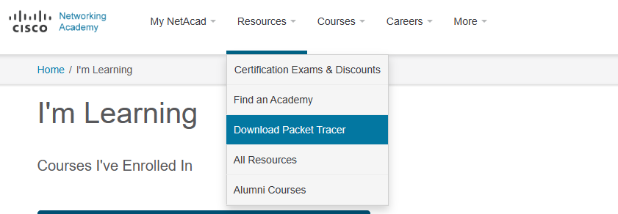
2. Finally download the Ubuntu version of Cisco Packet tracer.

(File name should be similar to “CiscoPacketTracer_821_Ubuntu_64bit.deb”)  
For reference follow: <https://www.sysnettechsolutions.com/en/install-packet-tracer-ubuntu/>

**Windows Users:**

Download Cisco Packet Tracer:  <https://www.netacad.com/courses/packet-tracer-download/>

1. It should be free after signing up.  It will ask you to watch a video, which will be helpful about how to use the software in the future, but not mandatory.
2. Then log in to the Cisco Network Academy and navigate to Resources > Download Packet Tracer (this is also explained in slide 2 of the “training”).  From there, you can use any Cisco device with everything just like the hardware version, but it is all virtual.

**Mac Users:**

1. For the students using MacOS, Cisco does not provide official support of Cisco Packet Tracer for MacOS. However, there are various third-party tools such as Wine that can help you install Cisco Packet Tracer on your MacBook. We request any student using MacOS to please reach us out on [*(the*](mailto:dege7805@colorad.edu) *course email ticketing address listed on the syllabus*) with their macOS version so that we can point out helpful links and support for installing Cisco Packet Tracer on Mac.
2. In case you are using macOS High Sierra, please follow the steps mentioned in the following link to install CPT on Mac: <https://www.sysnettechsolutions.com/en/ciscopackettracer/install-cisco-packet-tracer-7-1-on-macos-high-sierra/>. There is also a short video at the end of the webpage that provides a good walkthrough of the installation process.
3. Once that is done, create the following topology in Cisco Packer Tracer using available routers.
4. Provide a screenshot of the topology that you created in Cisco Packer Tracer. **[75 points]**

Total - /150 points